**Question 1:**

- Boolean is a kind of variable whose value is True of False

- Boolean expression: duc_is_handsome == False

nguyen_is_handsome == True

(1 + 1) == 2

**Question 2:**

- Flowchart is a type of diagram which show processes of a program by connecting boxes with arrows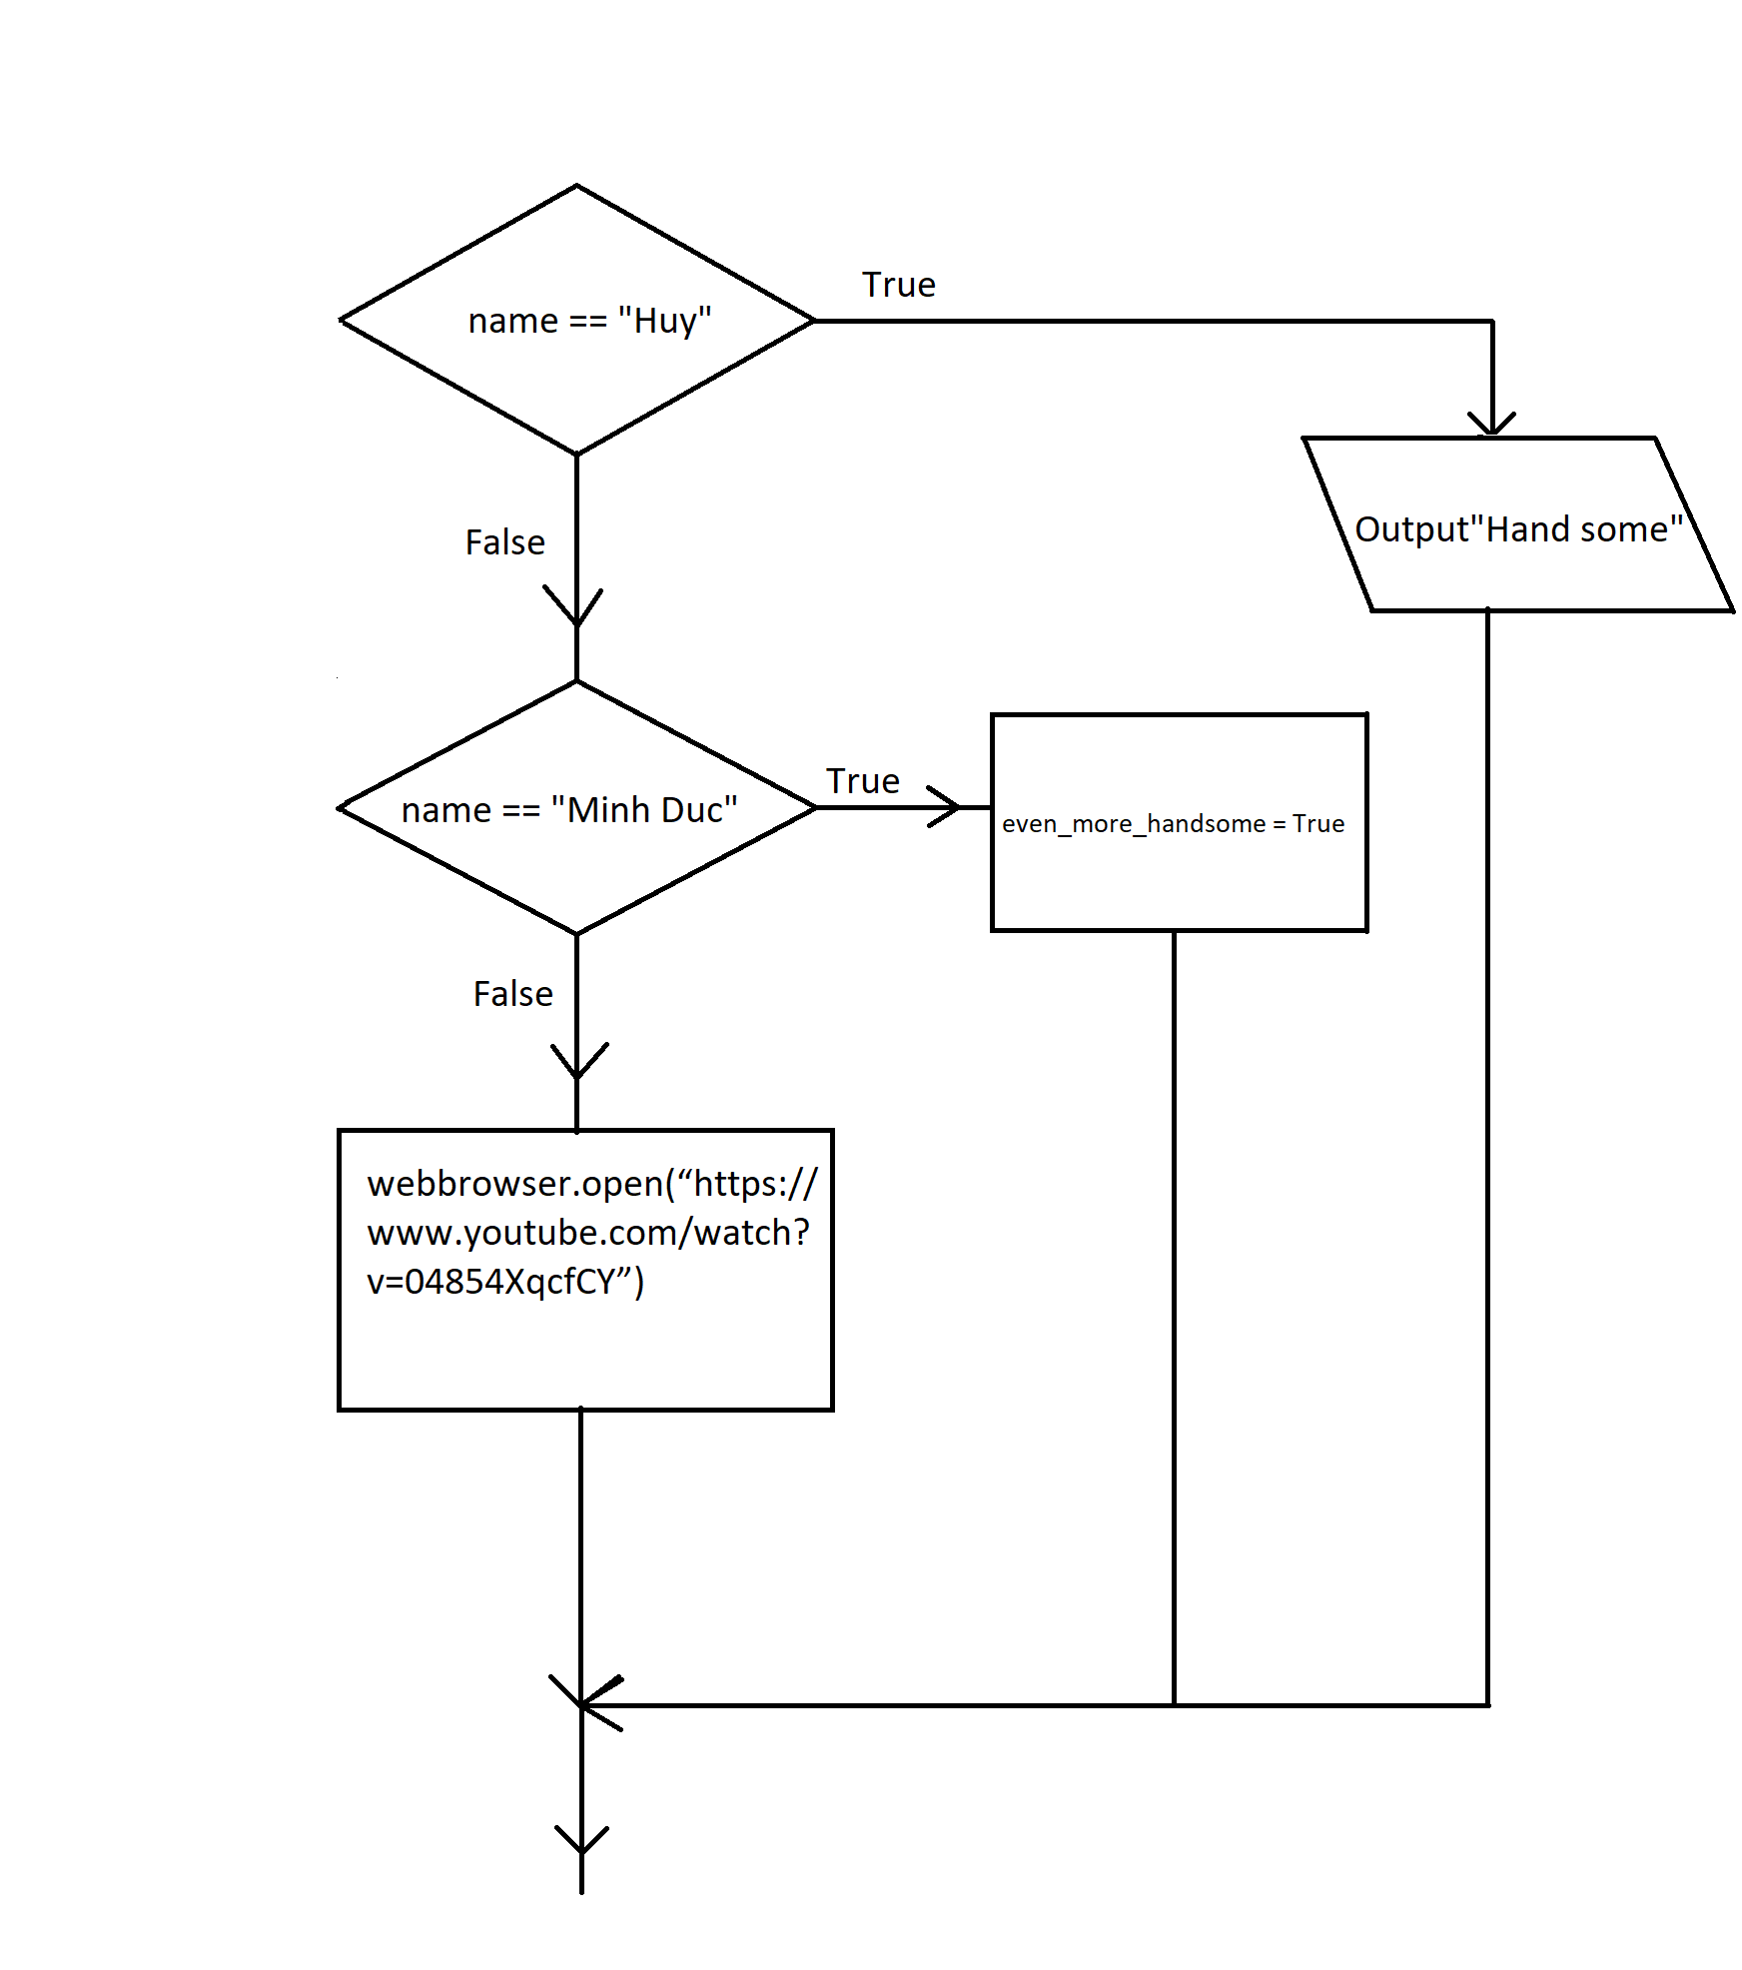

**Question 3:**

- Nested conditionals contain condition which is nest within another. Each branch may contain a if statement which has two branches of it own.

E.x:

yob = int(input(“Your year of birth: “))

current_year = 2018

age = current_year – yob

if age < 18:

if age < 10:

print(“Baby”)

elif age < 18:

print(“Teenager”)

else:

print(“Adult”)